**Exercise 1: Create a Jupyter Notebook Create a new Jupyter notebook called DataScienceEcosystem.ipynb**



**Exercise 2: Create markdown cell with title of the notebook.**

**Create a markdown cell with the title Data Science Tools and Ecosystem using H1 style heading.**

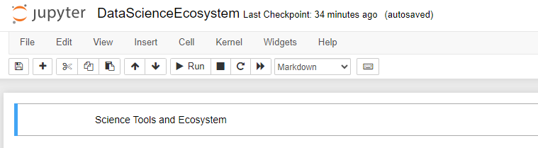

**Exercise 3 - Create a markdown cell for an introduction Write an introductory sentence about the notebook such as the follows: In this notebook, Data Science Tools and Ecosystem are summarized.**

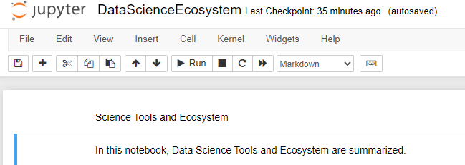

**Exercise 4 - Create a markdown cell to list data science languages Start the cell with an overview line such as: Some of the popular languages that Data Scientists use are:**

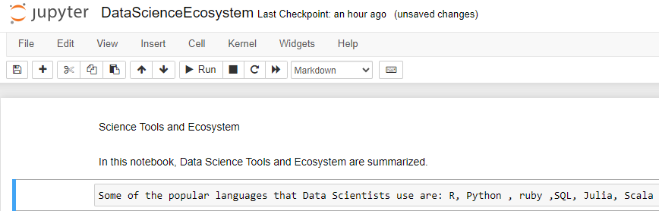

**Exercise 5 - Create a markdown cell to list data science libraries**

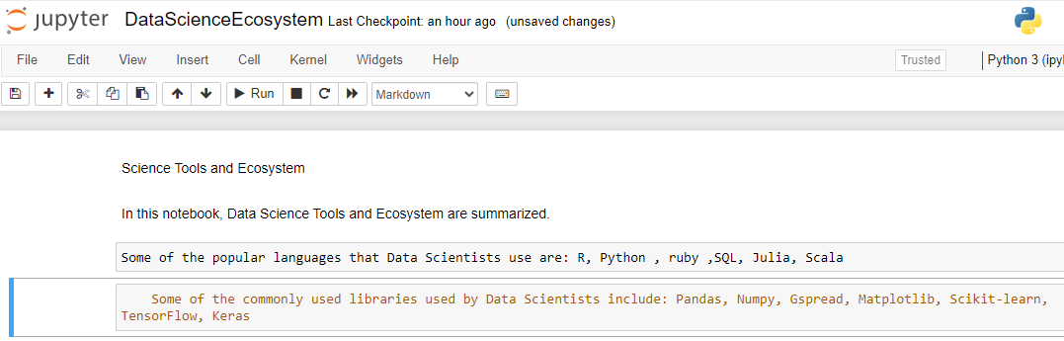

**Exercise 6 - Create a markdown cell with a table of Data Science tools**

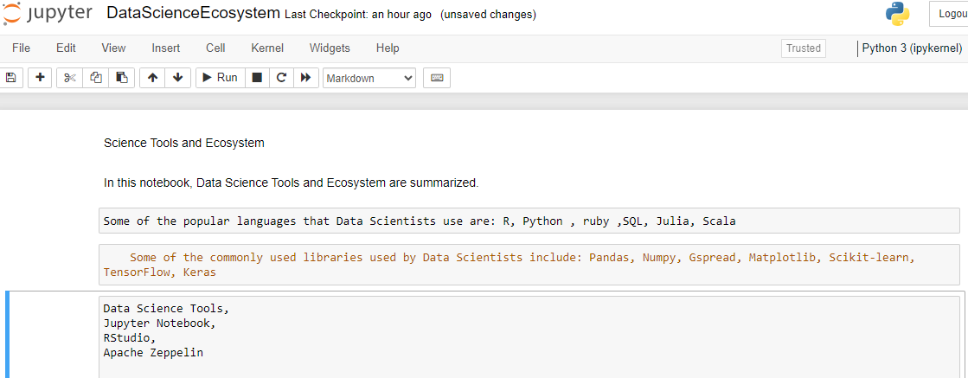

**Exercise 7 - Create a markdown cell introducing arithmetic expression examples Add a line in this cell with H3 style heading with text like:**

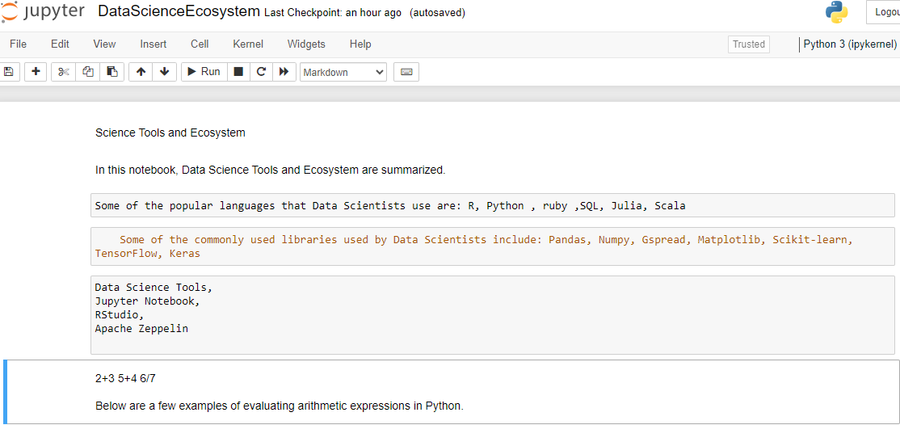

**Exercise 8 - Create a code cell to multiply and add numbers In this code cell evaluate the expression (3*4) +5. Insert a comment line before the expression to explain the operation e.g. This a simple arithmetic expression to mutiply then add integers. Then execute the cell to ensure the expression returns the expected output of 17.**

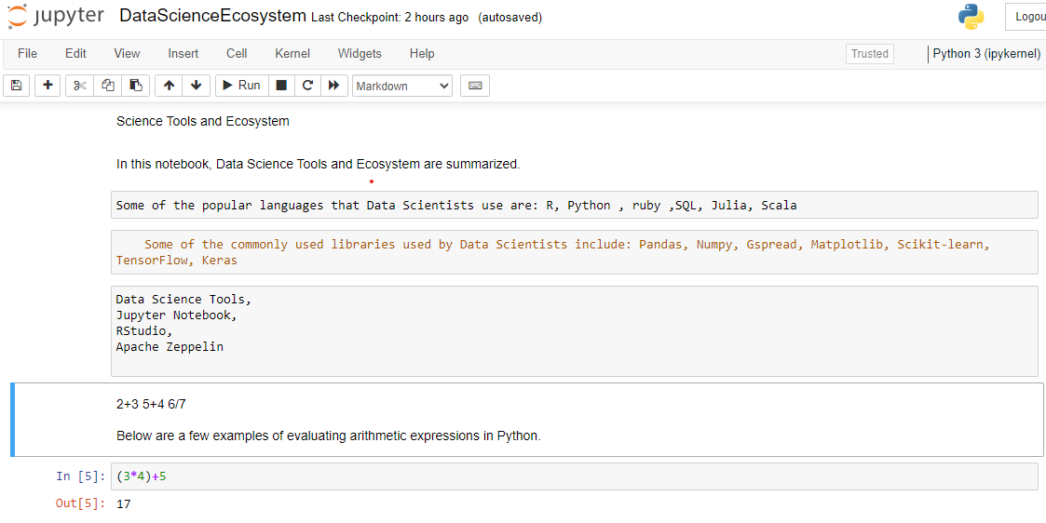

**Exercise 9 - Create a code cell to convert minutes to hours In this code cell write an expression that converts 200 minutes into hours. Insert a comment line before the expression to explain the operation e.g. This will convert 200 minutes to hours by diving by 60. Run the cell to evaluate the expression.**

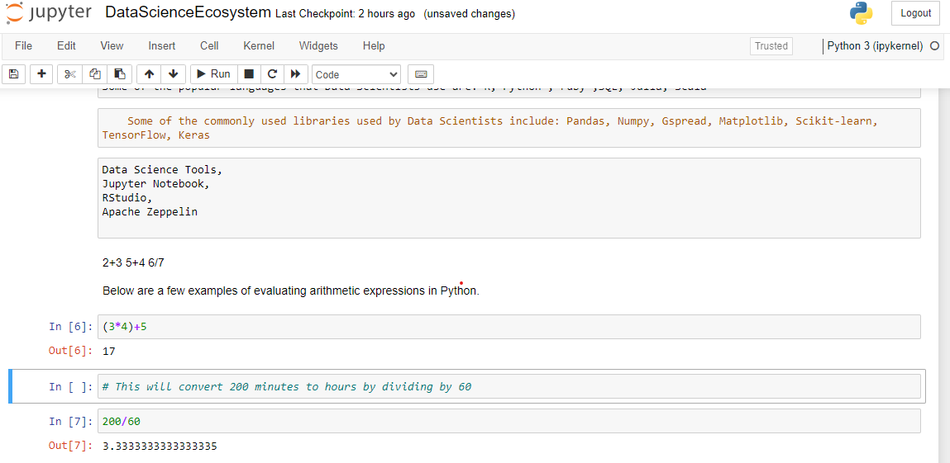

**Exercise 10 - Insert a markdown cell to list Objectives Below the introduction cell created in Exercise 3, insert a new markdown cell to list the objectives that this notebook covered (i.e. some of the key takeaways from the course). In this new cell start with an introductory line titled: Objectives: in bold font. Then using an unordered list (bullets) indicate 3 to 5 items covered in this notebook, such as List popular languages for Data Science.**

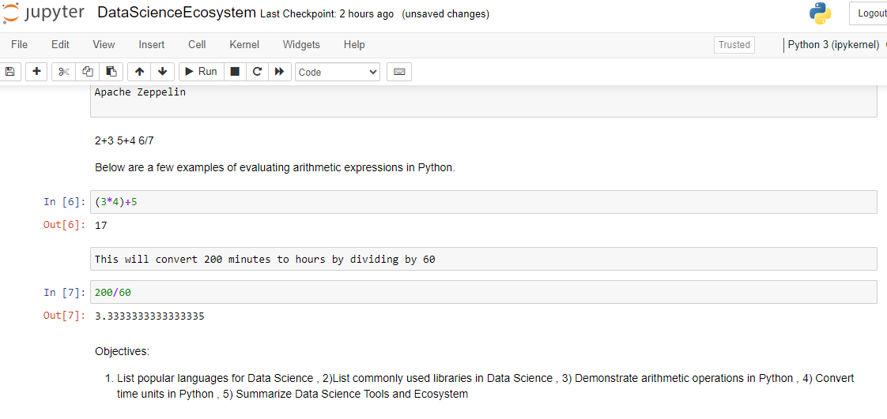

**Exercise 11 - Create a markdown cell to indicate the Author's name**

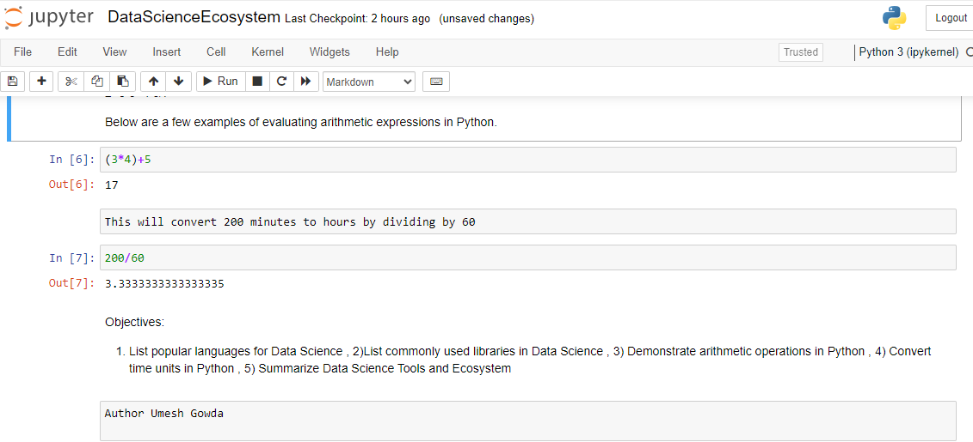

**Exercise 12 - Share your notebook through GitHub**

